|  |
| --- |
|  |
| Team 5 Baseline |
| Advising System Prototype |
|  |
| **Bryon Miller, Sai Namilakonda, Andre Ndongosieme** |
| **3/2/2020** |

The document contains the baseline prototype for the Advising System developed for UNA by Team 5. This project is for the assignment in CIS 615 at UNA, Spring 2020.

Table of Contents

[To update the table of contents, right click the message below and select Update Field (F9 on PC, ⌥⌘U on Mac).]

1. Pages 4

1.1. Page Tree 4

1.2. Advisee Sign In 5

1.2.1. User Interface 5

1.3. Sign In Error 6

1.3.1. User Interface 6

1.4. Advisor Sign In 7

1.4.1. User Interface 7

1.5. Sign In Error 8

1.5.1. User Interface 8

1.6. Advisee Home 9

1.6.1. User Interface 9

1.7. Advisee Degree Plan 10

1.7.1. User Interface 10

1.8. Advisee Course Schedule 11

1.8.1. User Interface 11

1.9. Advisee Schedule Results 12

1.9.1. User Interface 12

1.10. Advisee Register 13

1.10.1. User Interface 13

1.11. Advisor Home 14

1.11.1. User Interface 14

1.12. Advisor Degree Plan 15

1.12.1. User Interface 15

1.13. Advisor Course Schedule 16

1.13.1. User Interface 16

1.14. Advisor Schedule Results 17

1.14.1. User Interface 17

1.15. Advisor Register 18

1.15.1. User Interface 18

1. Pages
   1. Page Tree

Advisee Sign In  
 Sign In Error  
Advisor Sign In  
 Sign In Error  
Advisee Home  
 Advisee Degree Plan  
 Advisee Course Schedule  
 Advisee Schedule Results  
 Advisee Register  
Advisor Home  
 Advisor Degree Plan  
 Advisor Course Schedule  
 Advisor Schedule Results  
 Advisor Register

* 1. Advisee Sign In
     1. User Interface

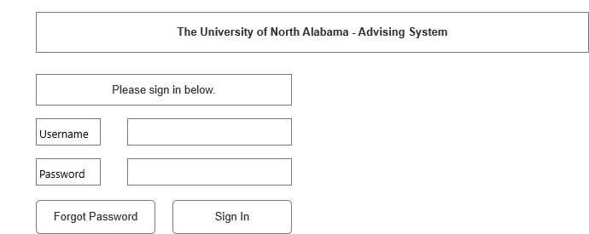

* 1. Sign In Error
     1. User Interface

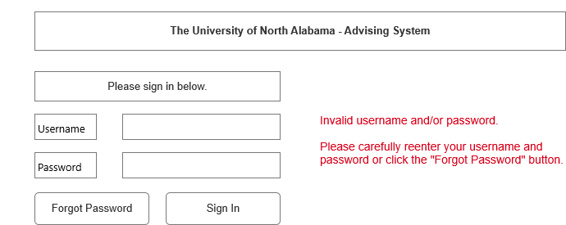

* 1. Advisor Sign In
     1. User Interface



* 1. Sign In Error
     1. User Interface



* 1. Advisee Home
     1. User Interface

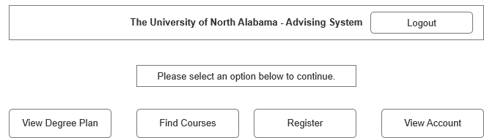

* 1. Advisee Degree Plan

ary

* + 1. User Interface

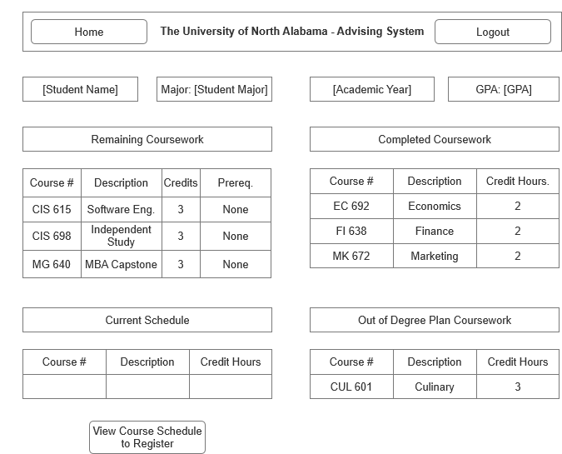

* 1. Advisee Course Schedule
     1. User Interface

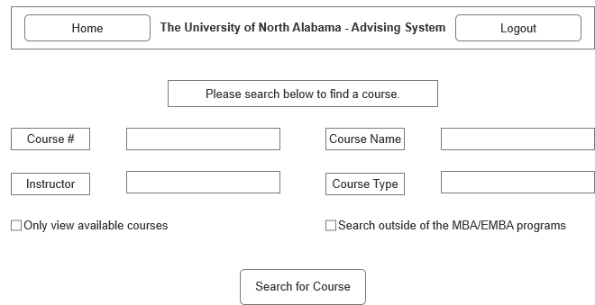

* 1. Advisee Schedule Results
     1. User Interface

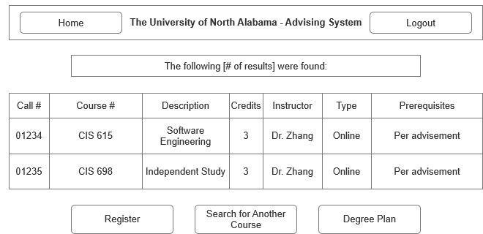

* 1. Advisee Register
     1. User Interface

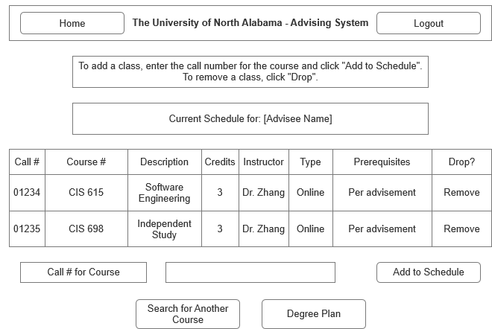

* 1. Advisor Home
     1. User Interface

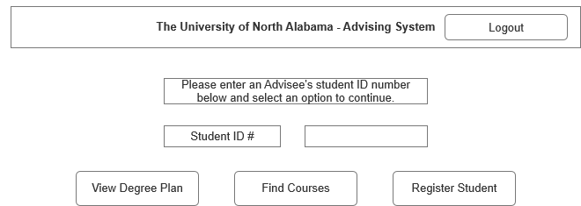

* 1. Advisor Degree Plan

ary

* + 1. User Interface



* 1. Advisor Course Schedule
     1. User Interface



* 1. Advisor Schedule Results
     1. User Interface

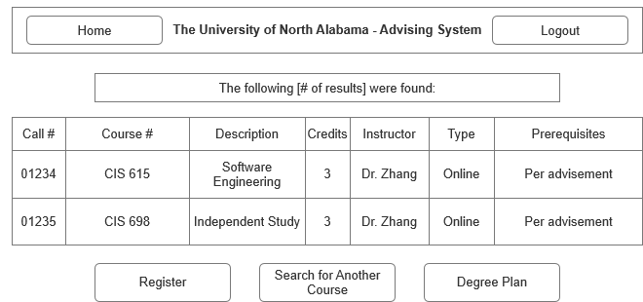

* 1. Advisor Register
     1. User Interface

